# **REFERENCE LINES – Yearly Profits of the Categories**

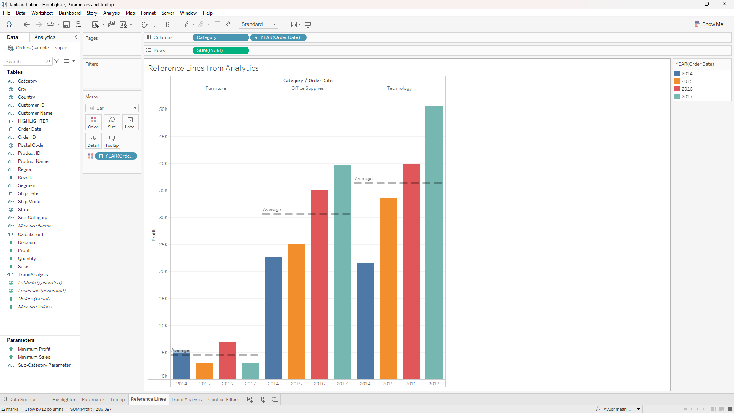

# **TREND ANALYSIS - of monthly profits of different categories**

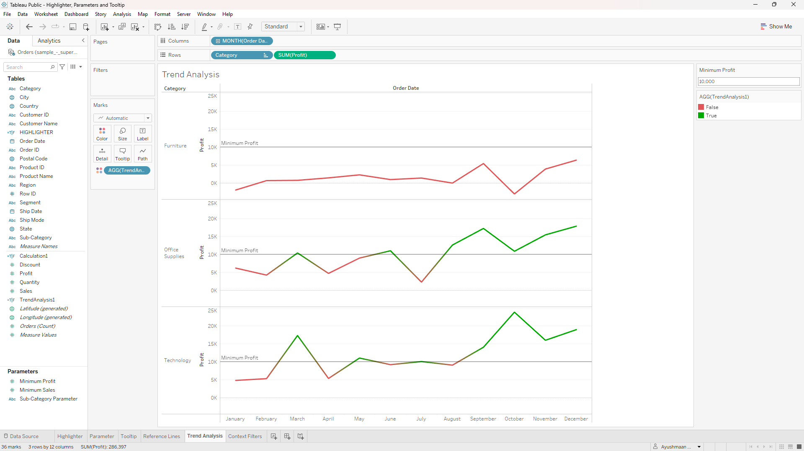

# **CONTEXT FILTER**

# 